**Model Development Phase Template**

|  |  |
| --- | --- |
| Date | 10 July 2024 |
| Team ID | SWTID1720162737 |
| Project Title | Predicting Compressive Strength Of Concrete Using Machine Learning |
| Maximum Marks | 4 Marks |

**Initial Model Training Code, Model Validation and Evaluation Report**

The initial model training code will be showcased in the future through a screenshot. The model validation and evaluation report will include classification reports, accuracy, and confusion matrices for multiple models, presented through respective screenshots.

**Initial Model Training Code:**

* Importing and building linear regression model:

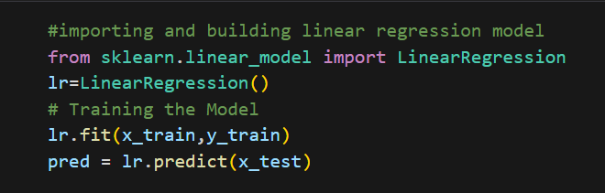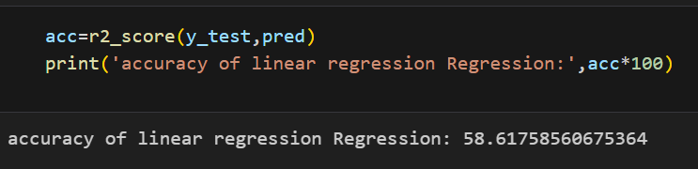

* Importing and building Ridge Regression:

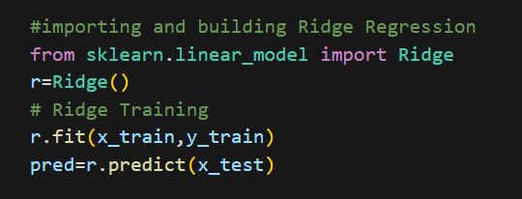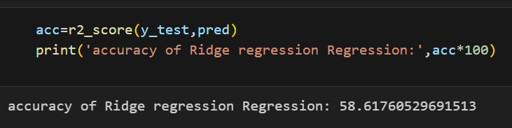

* Importing and Building Lasso Regression:

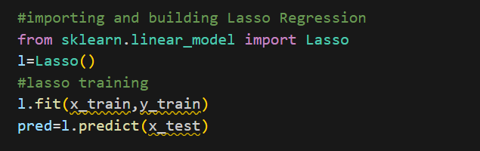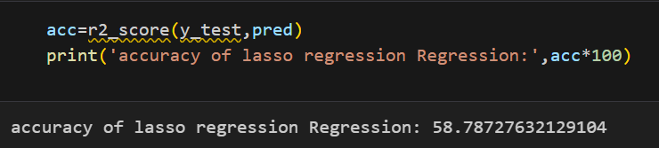

* Importing and Building Decision Tree Regression:

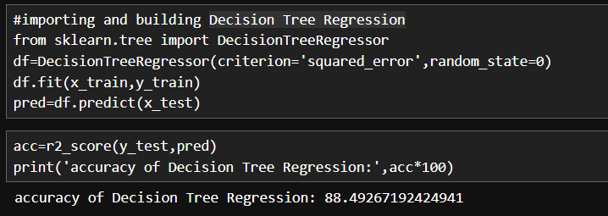

* Importing and Building Random Forest Regression using GridSearchCV:

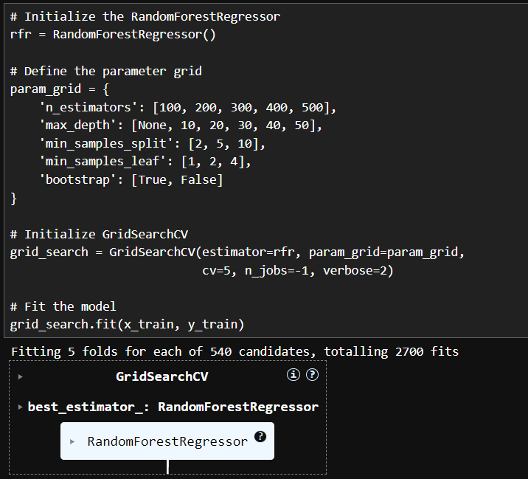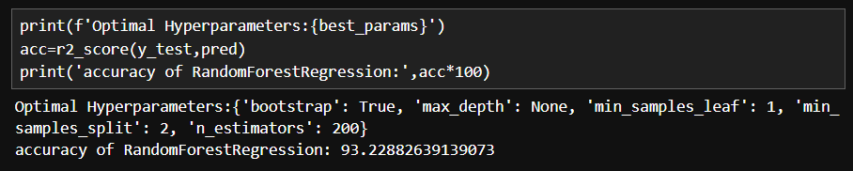

* Importing and Building Gradient Boosting Regression using GridSearchCV:

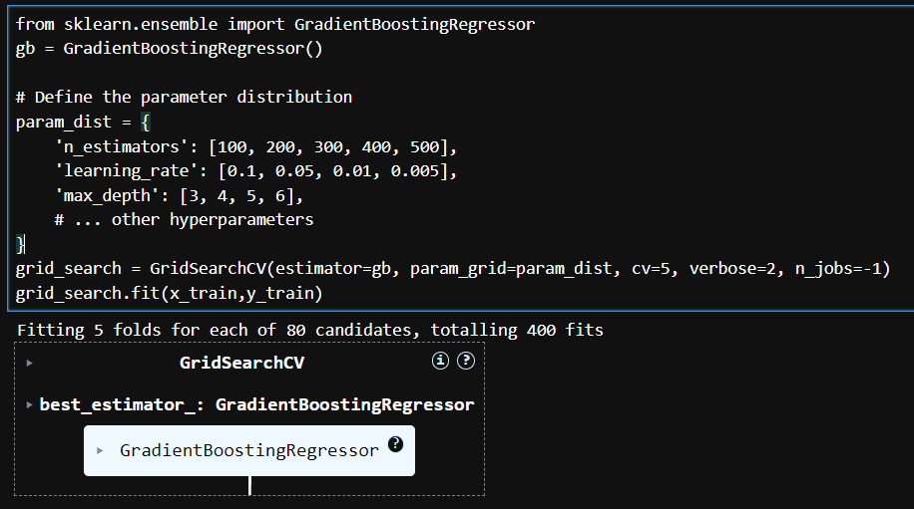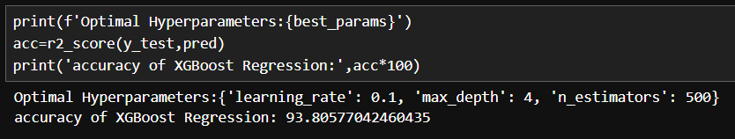

* Importing and Building XG Boost Regression using RandomizedSearchCV:

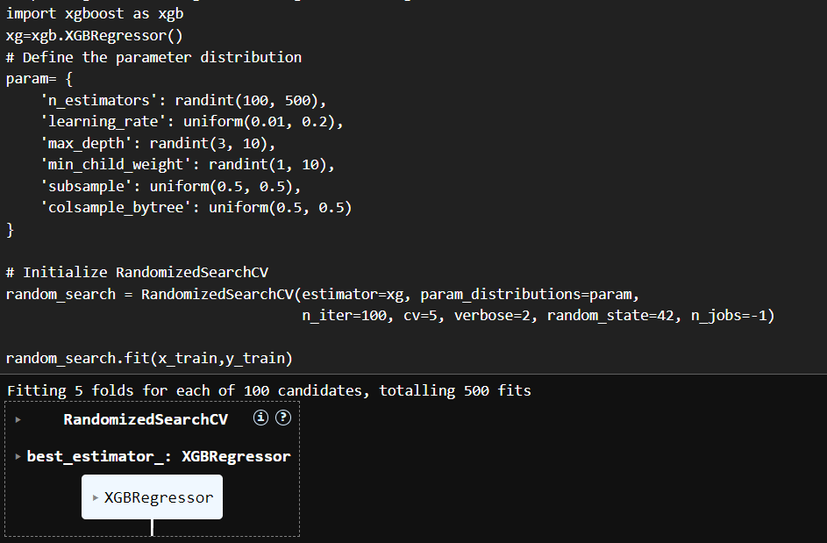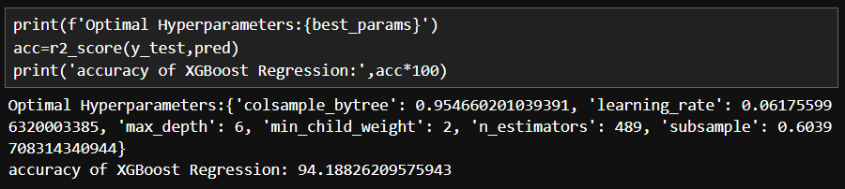

**Model Validation and Evaluation Report:**

|  |  |  |  |
| --- | --- | --- | --- |
| **Model** | Mean Squared Error  Mean Absolute Error | **Accuracy**  **(**R2 Score) | RMSE |
| Linear Regression |  | 58.61 % |  |
| Ridge Regression |  | 58.62% |  |
| Lasso Regression |  | 58.78 % |  |
| Random Forest Regression |  | 93.23% |  |
| Decision Tree Regression |  | 88.49% |  |
| Gradient Boosting regression |  | 93.8% |  |
| XGBoost Regression |  | 94.18% |  |